OBSERVATIONS

Part 1: Amplitude modulation of signals in time domain and frequency domain

a. Sinusoidal signal:

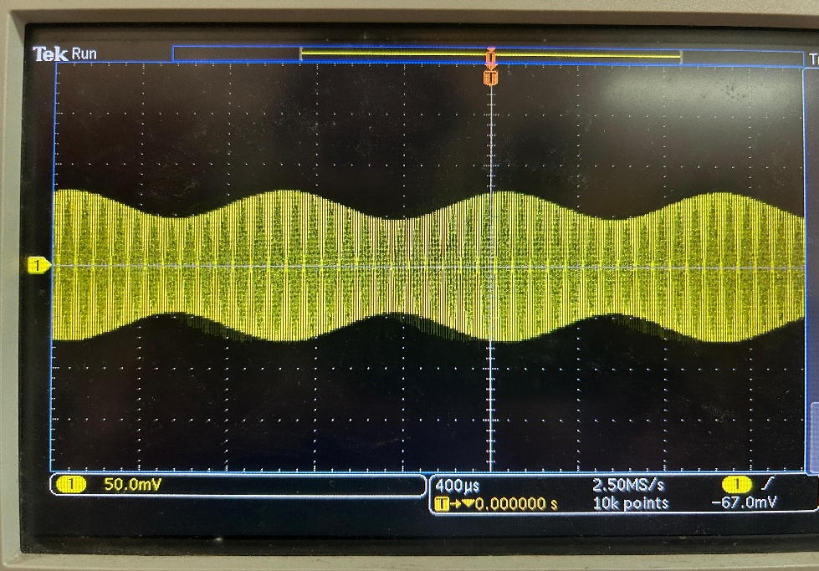

Figure 1: Amplitude modulated signal of a sinusoidal waveform in time domain for $μ=0.25$

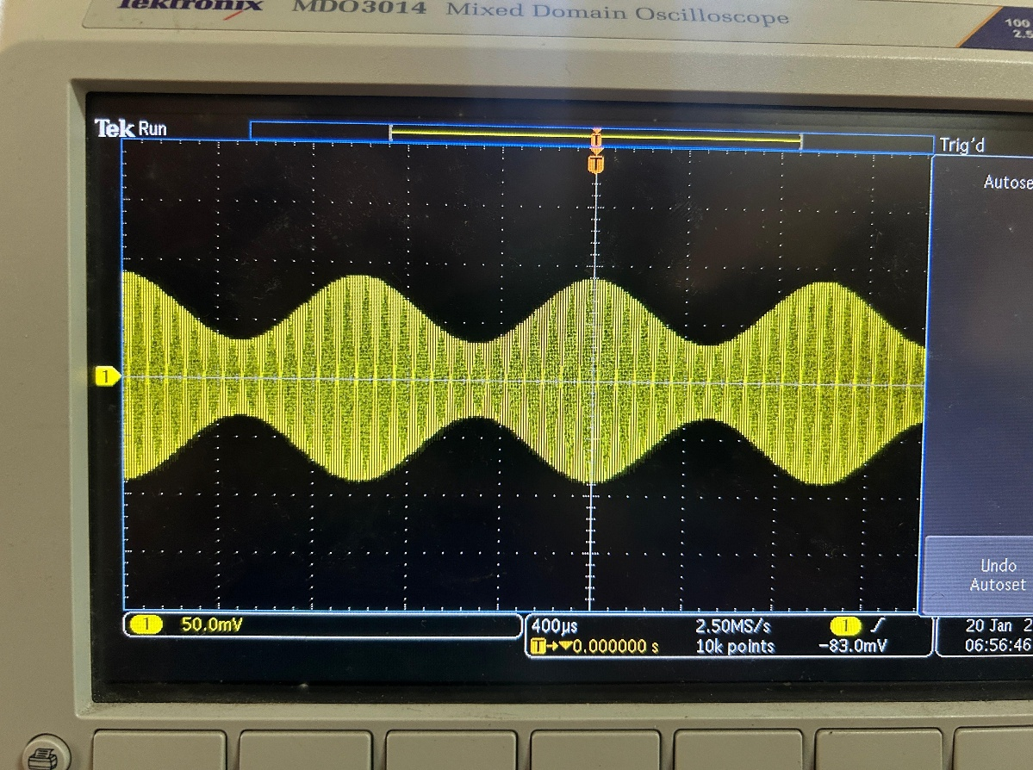

Figure 2: Amplitude modulated signal of a sinusoidal waveform in time domain for $μ=0.5$

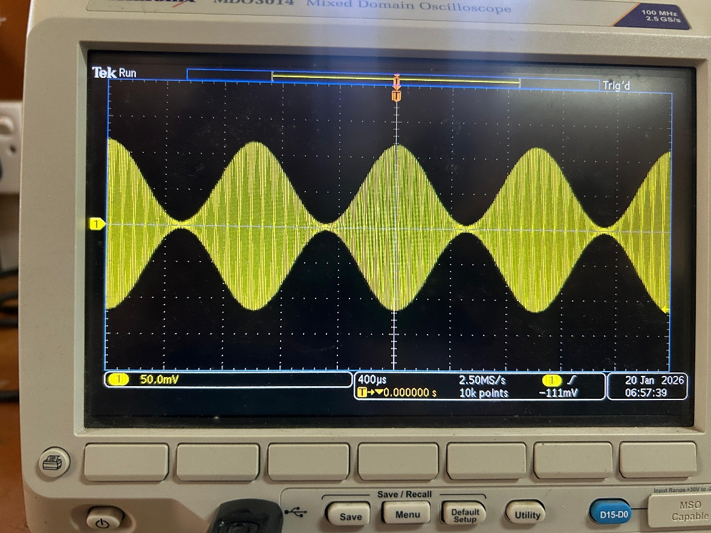

Figure 3: Amplitude modulated signal of a sinusoidal waveform in time domain for $μ=1.0$

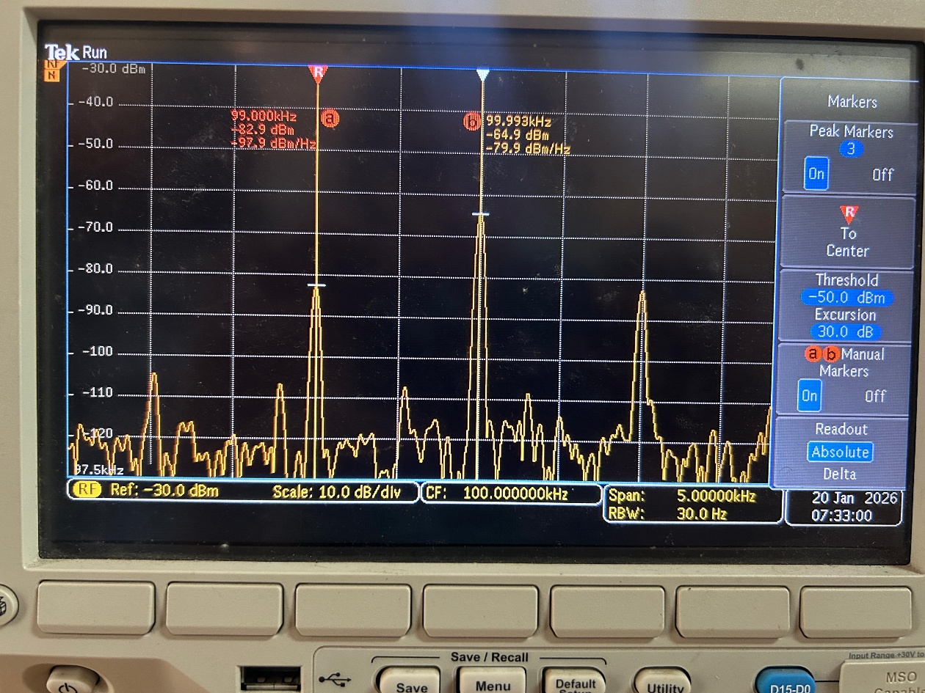

Figure 4: Amplitude modulated signal of a sinusoidal waveform in frequency domain for $μ=0.25$

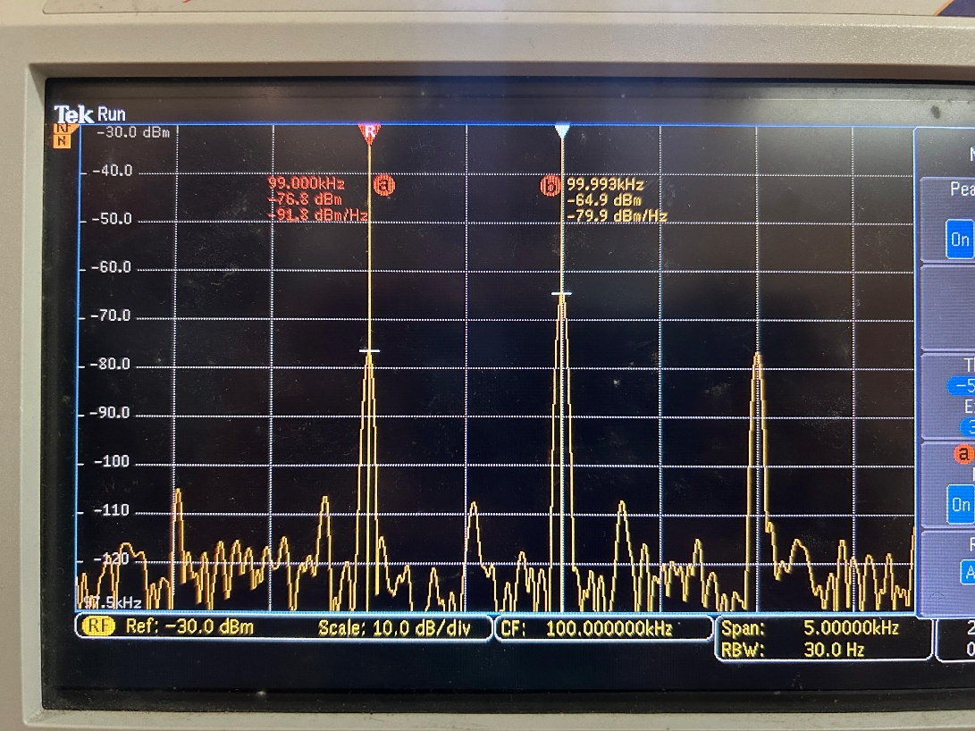

Figure 5: Amplitude modulated signal of a sinusoidal waveform in frequency domain for $μ=0.5$

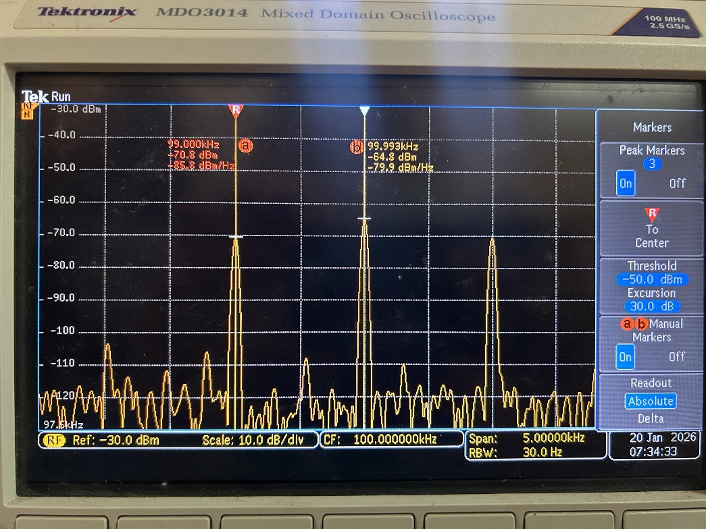

Figure 6: Amplitude modulated signal of a sinusoidal waveform in frequency domain for $μ=1.0$

b. Square wave signal:

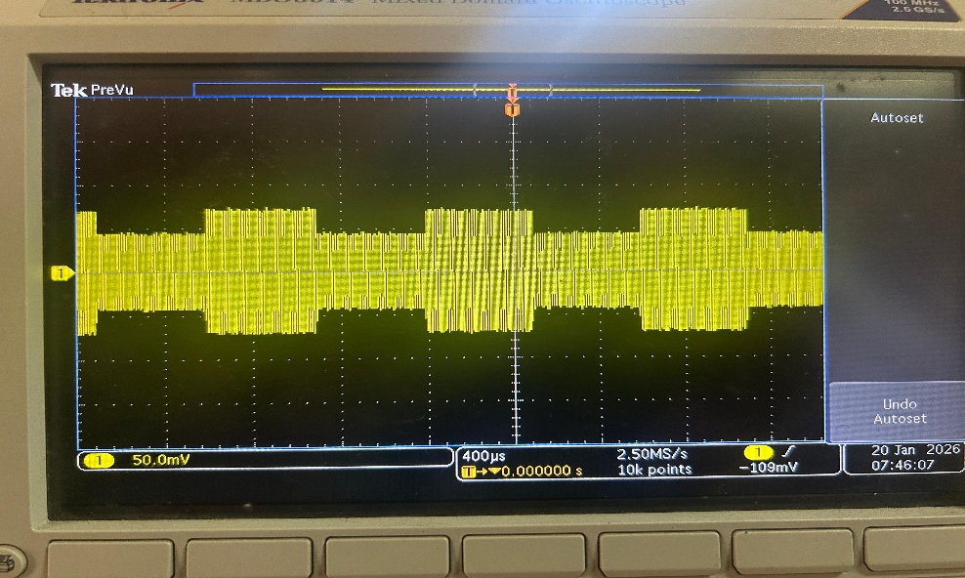

Figure 7: Amplitude modulated signal of a square waveform in time domain for $μ=0.25$

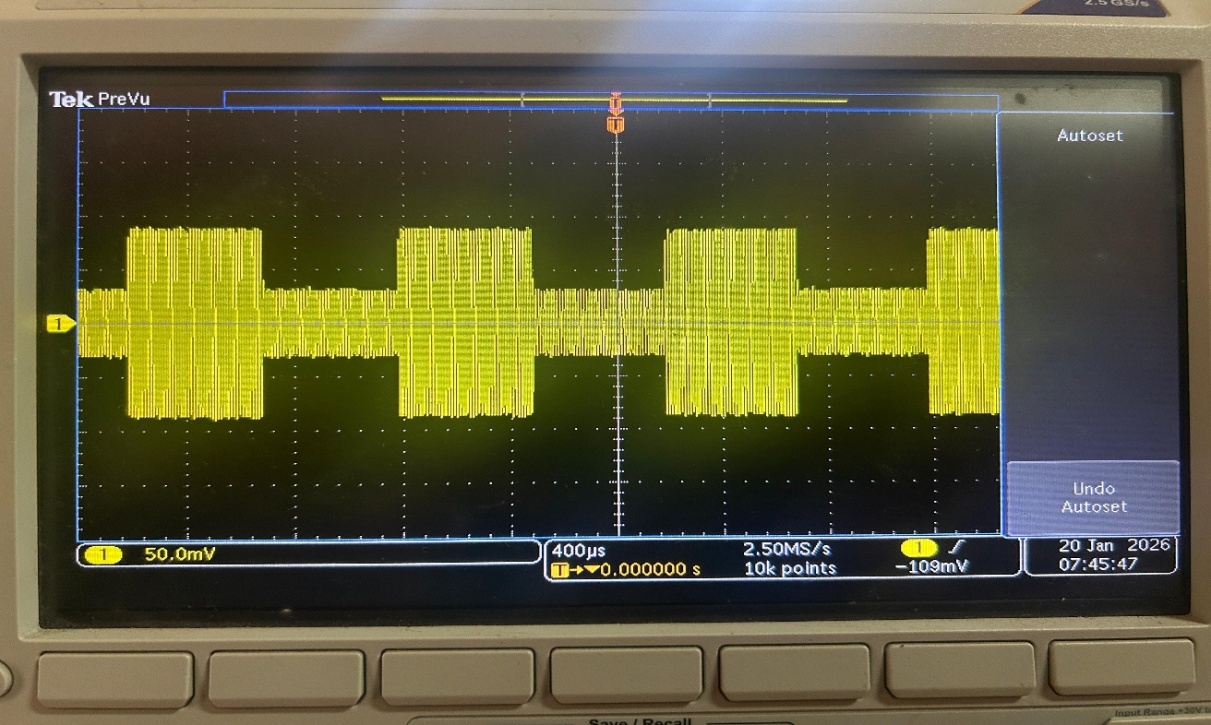

Figure 8: Amplitude modulated signal of a square waveform in time domain for $μ=0.5$

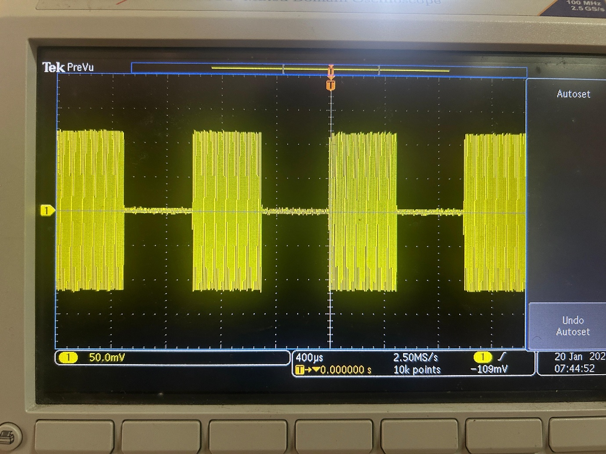

Figure 9: Amplitude modulated signal of a square waveform in time domain for $μ=1.0$

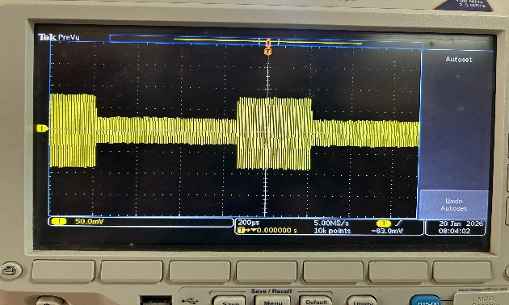

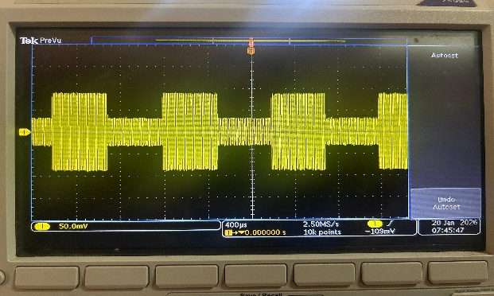

Figure 10: With duty ratio = 25% Figure 11: With duty ratio = 50%

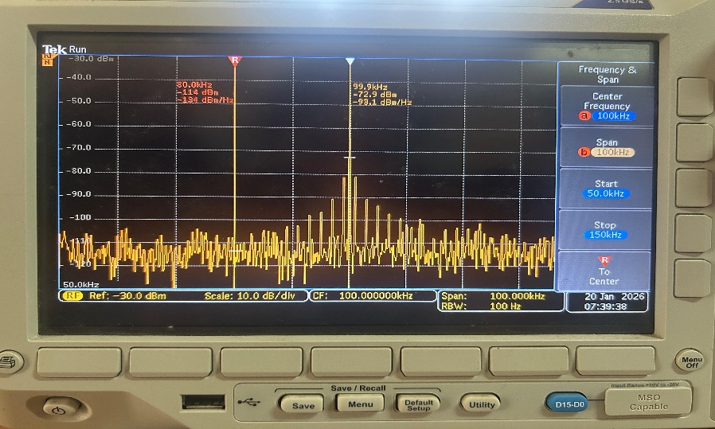

Figure 12: Amplitude modulated signal of a square waveform in frequency domain for $μ=0.25$

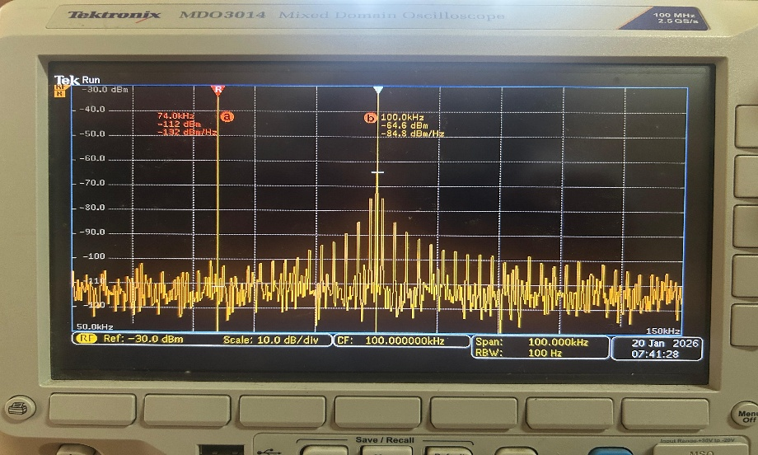

Figure 13: Amplitude modulated signal of a square waveform in frequency domain for $μ=0.5$

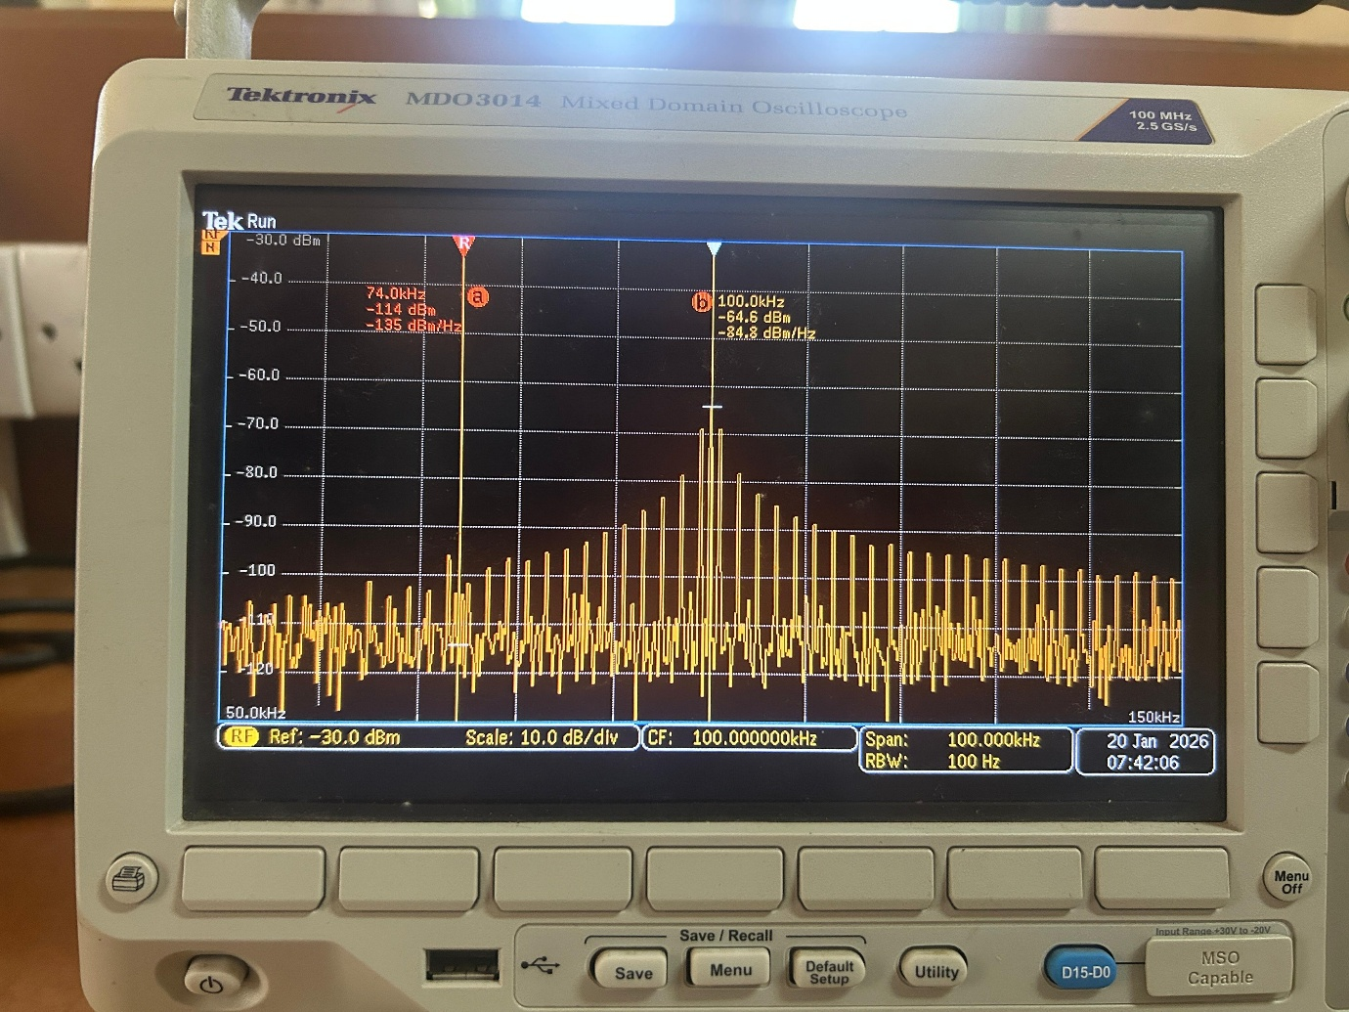

Figure 14: Amplitude modulated signal of a square waveform in frequency domain for $μ=1.0$

1. Triangular pulse signal:

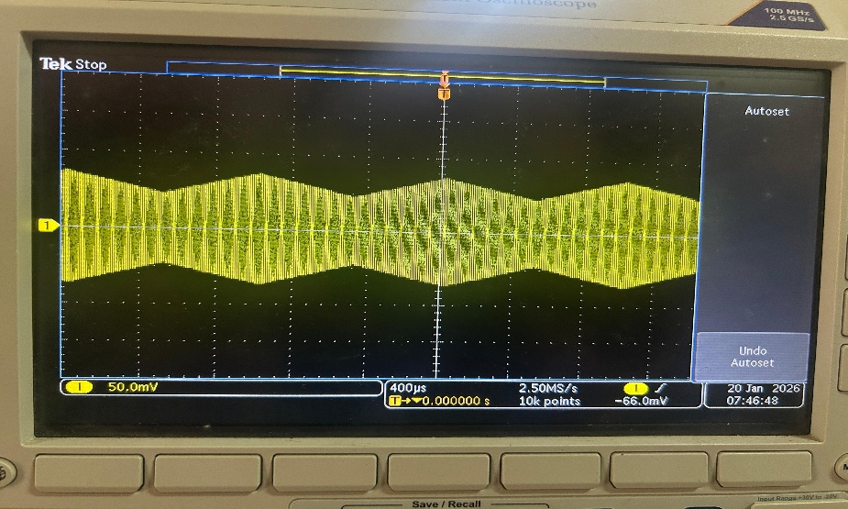

Figure 15: Amplitude modulated signal of a triangular pulse waveform in time domain for $μ=0.25$

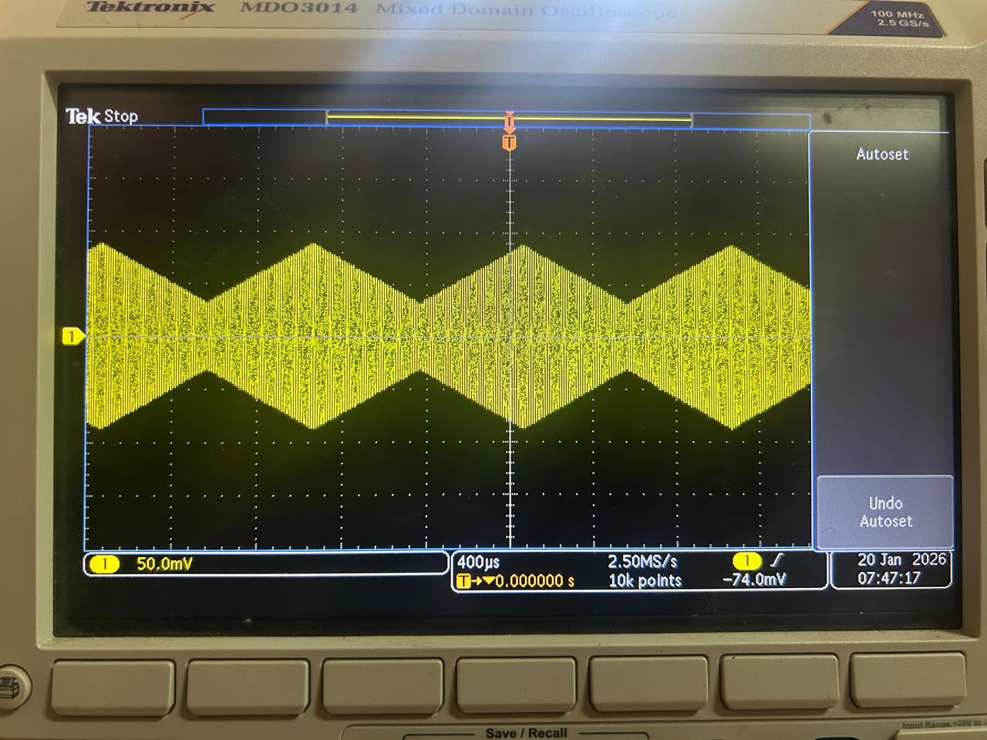

Figure 16: Amplitude modulated signal of a triangular pulse waveform in time domain for $μ=0.5$

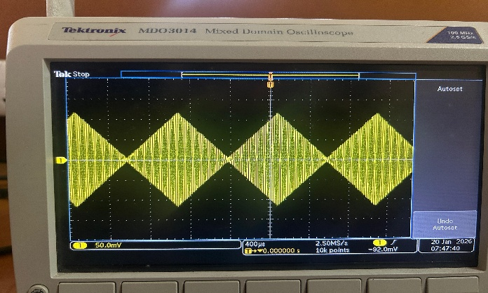

Figure 17: Amplitude modulated signal of a triangular pulse waveform in time domain for $μ=1.0$

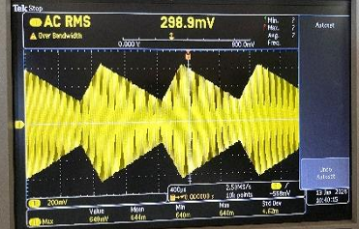

Figure 18: With duty ratio = 25% Figure 19: With duty ratio = 50%

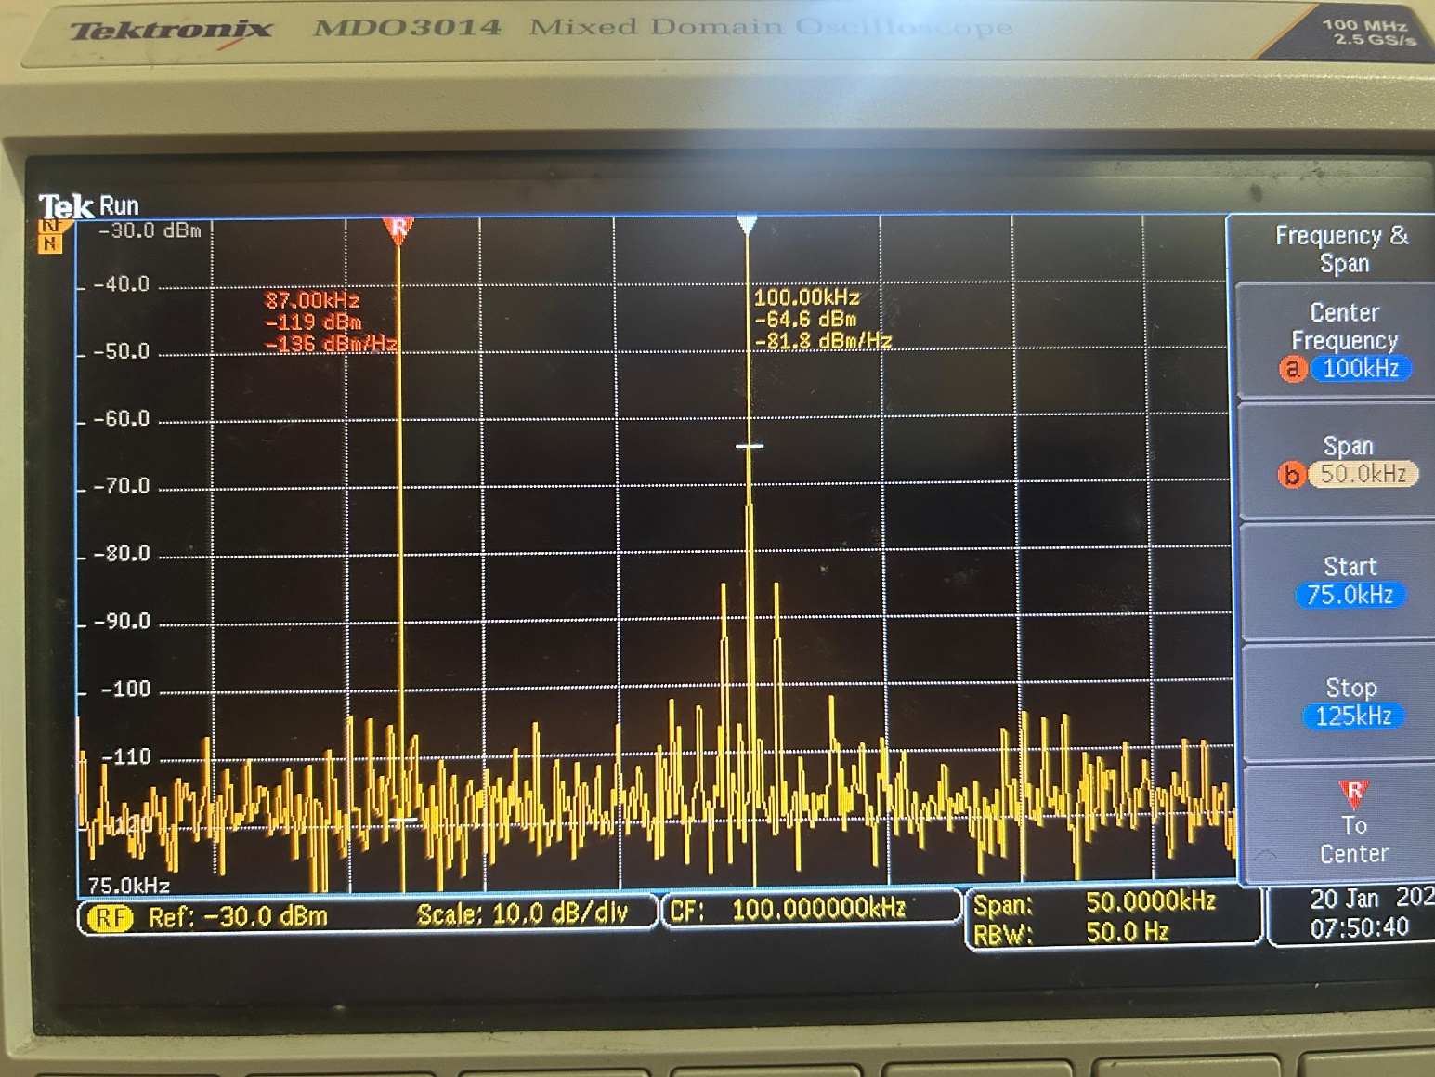

Figure 20: Amplitude modulated signal of a triangular pulse waveform in frequency domain for $μ=0.25$

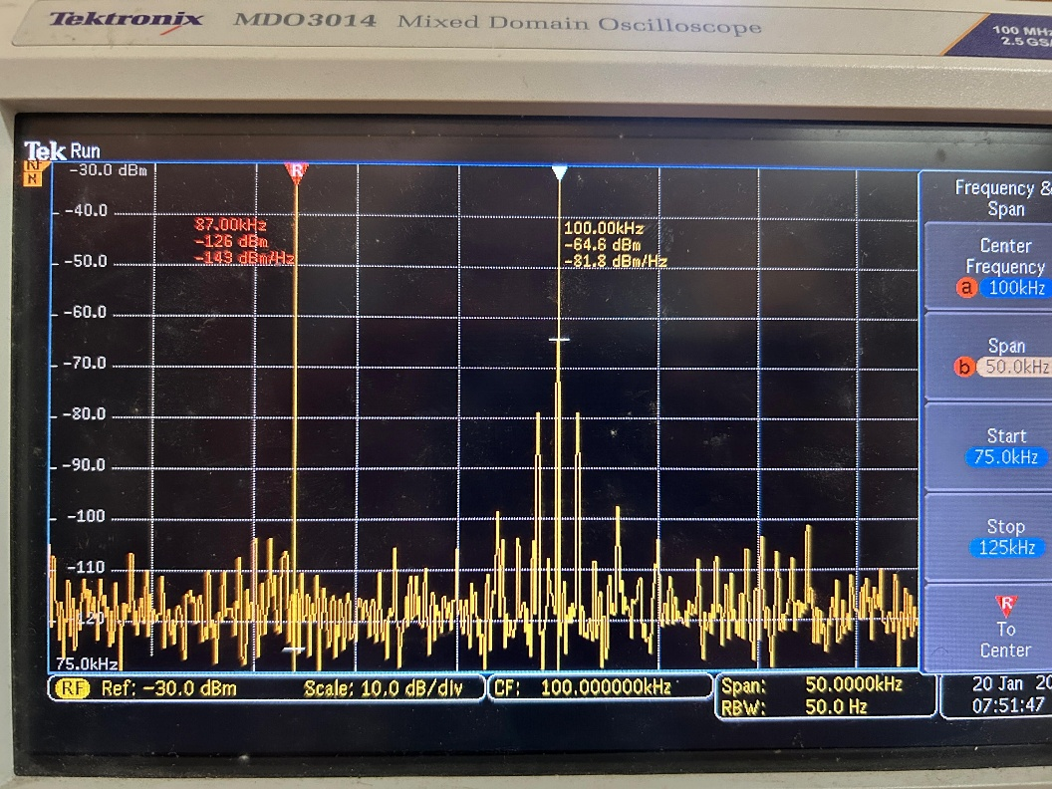

Figure 21: Amplitude modulated signal of a triangular pulse waveform in frequency domain for $μ=0.5$

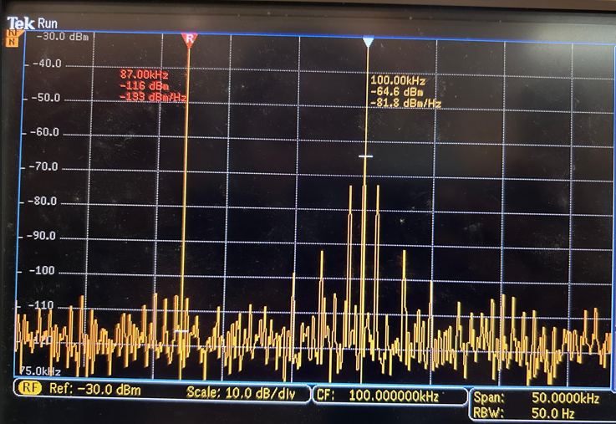

Figure 22: Amplitude modulated signal of a triangular pulse waveform in frequency domain for $μ=1.0$

**Part 2: Amplitude de-modulation using envelop detection**

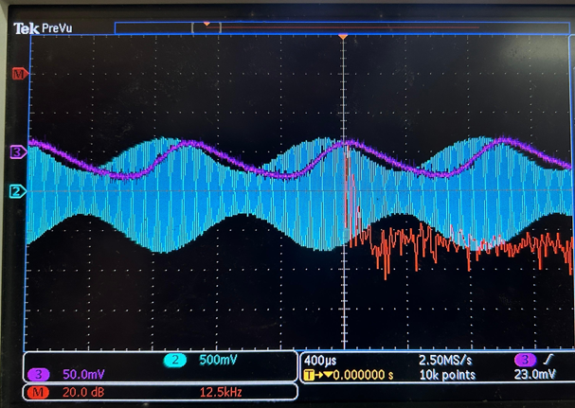

Figure 23: Modulated And De-modulated signal in time domain and frequency domain